Outputs
Question 1: Types of text formattings
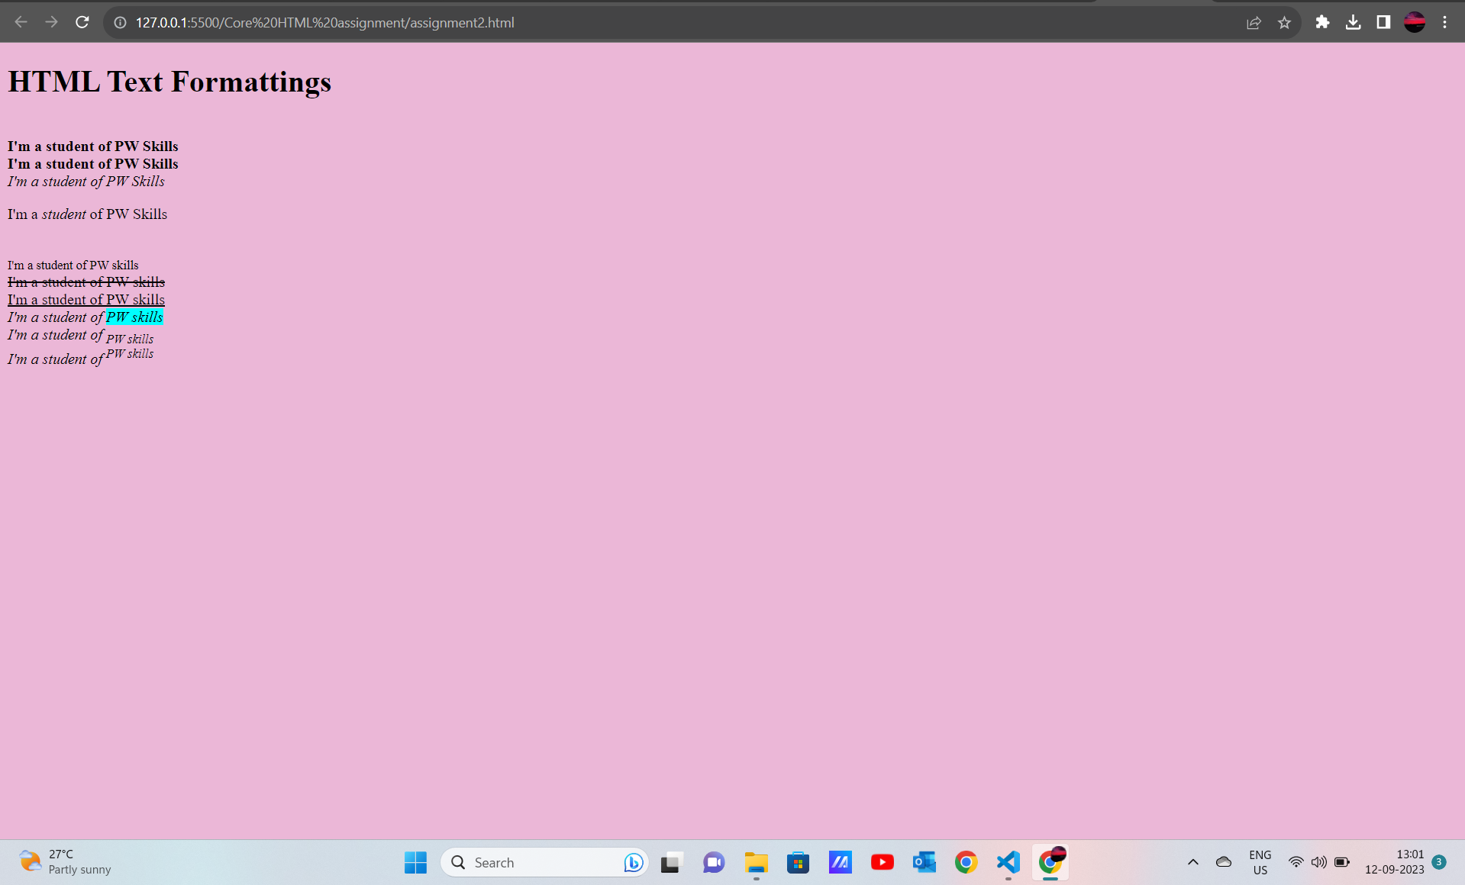

Question 2: Simple web page that navigates users to different page on click
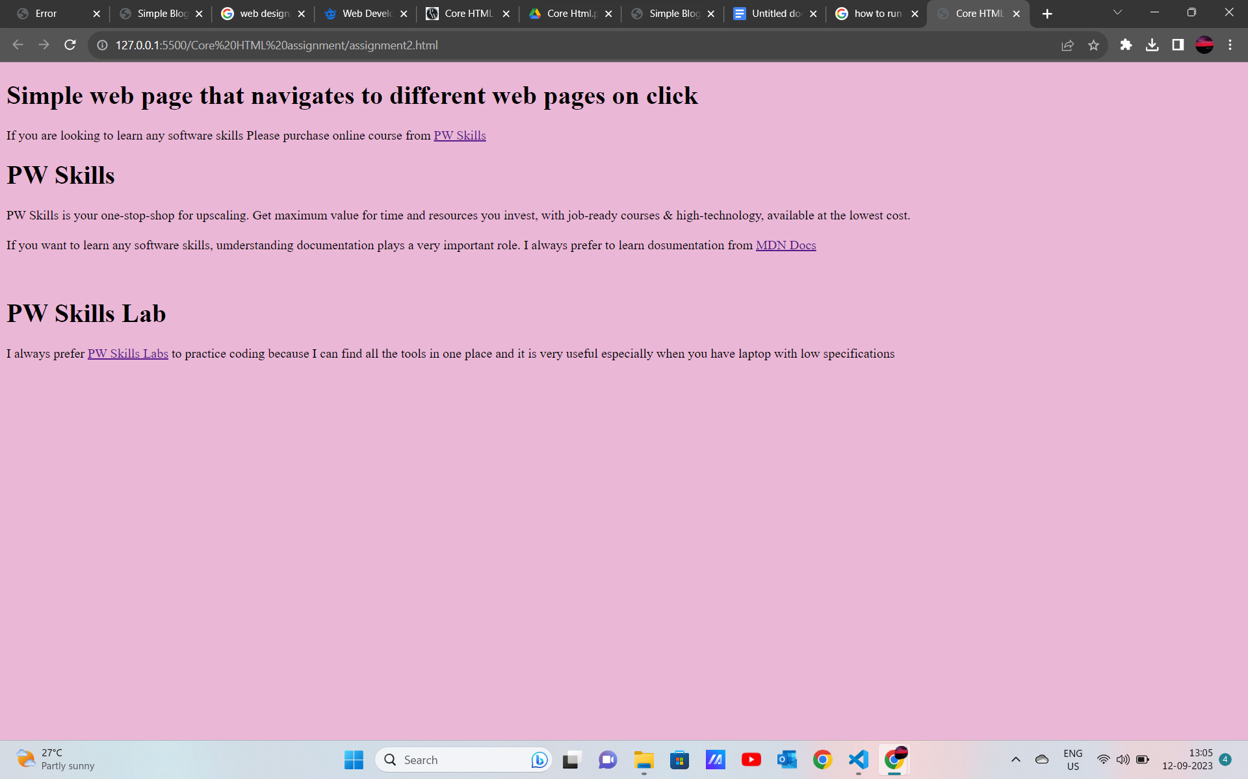

Question 4: Ordered list of HTMl tags. Each list containing tag name and some information of tag
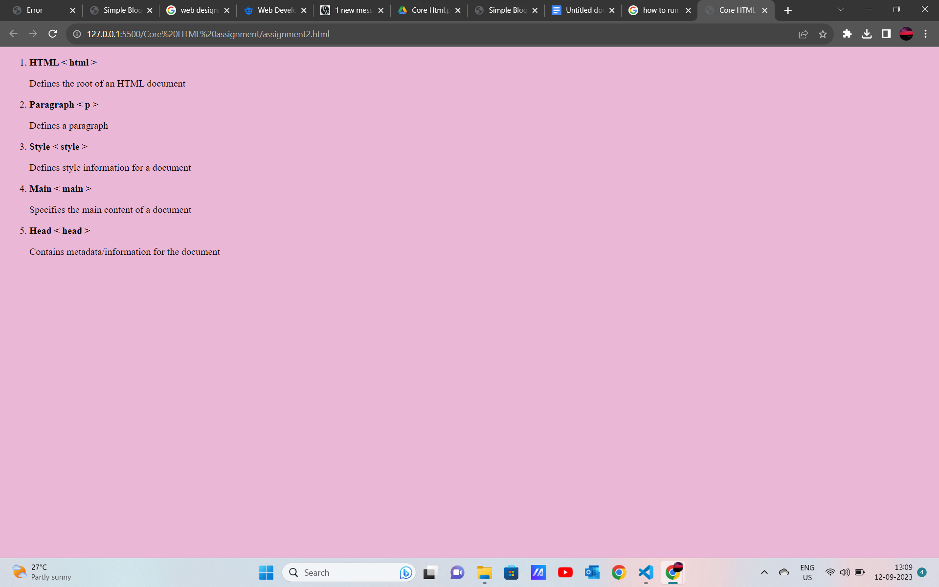

Question 5: Description list of full stack web development tech stack using <dl> tag.
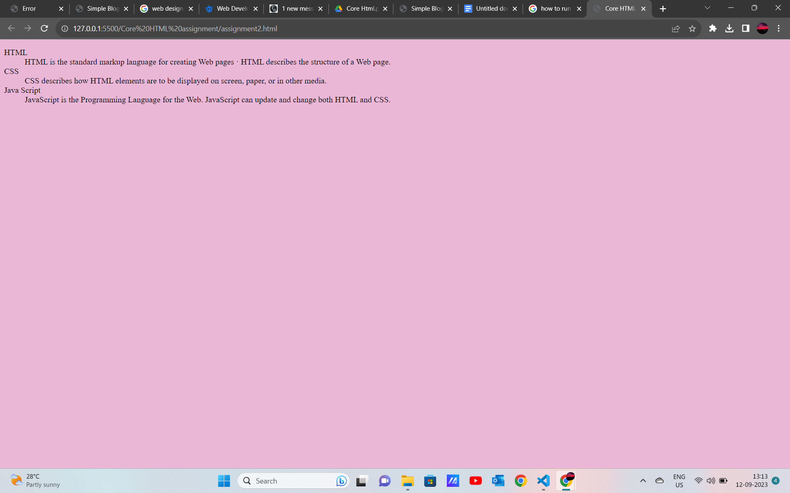
Question 6: Ordered list of full stack web development tech stackHTML, CSS, JS. For each tech stack create a table consisting of tech stack name, primary features and key benefits.
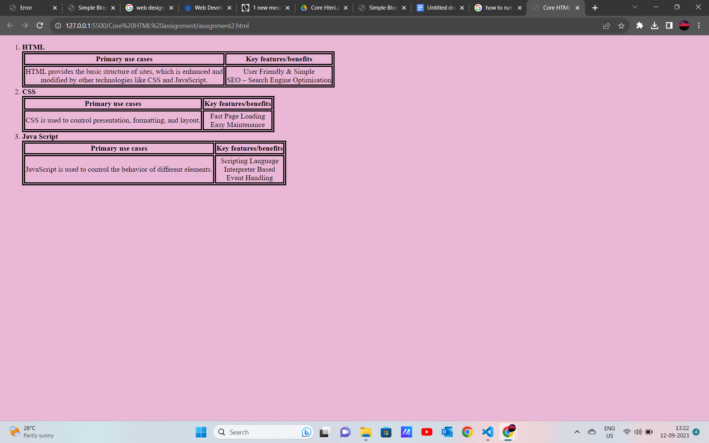

Question 7: Build complex nested list structure representing a multi-level table of content. Use <ul> and <li> with inline-block styling and use text formats to enhance the persentation.
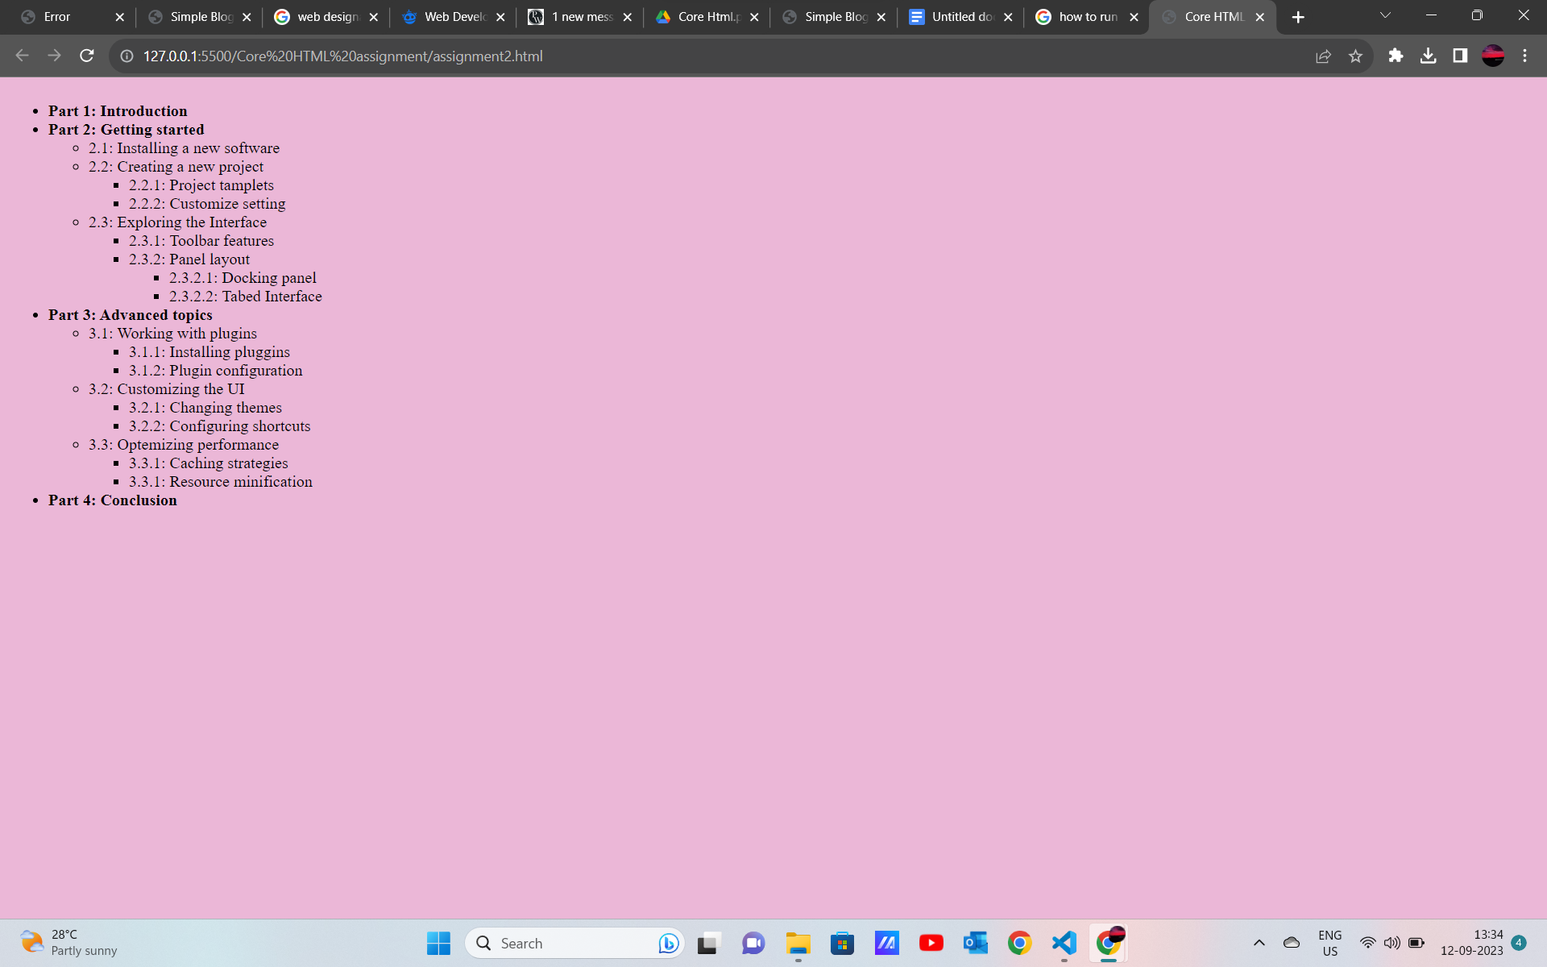
Question 8: Table to display a conference schedule
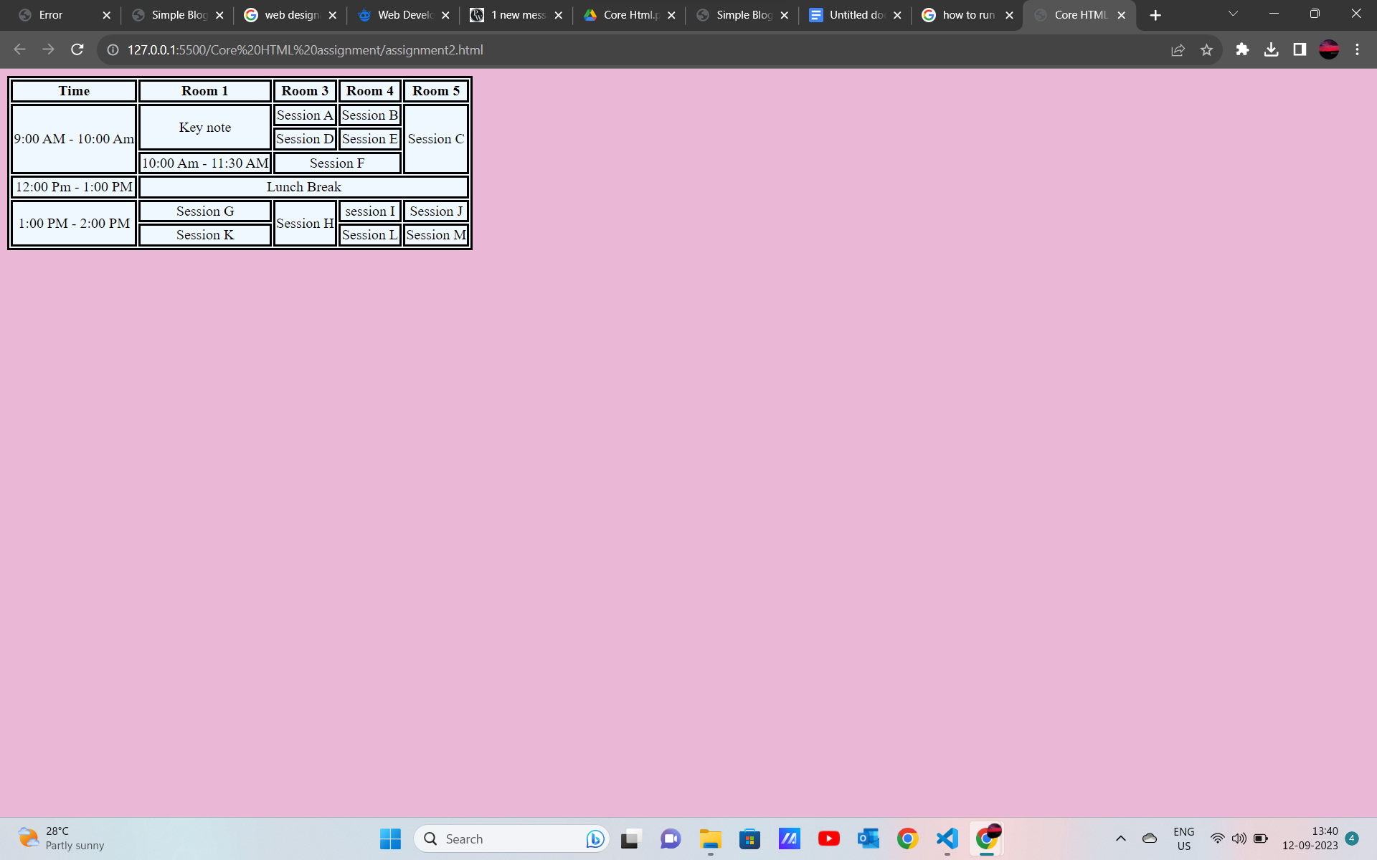
Question 3: Simple blog page with three web pages home, web development and web design.
